**Disclaimer. Please do not copy these exactly, I made a mistake he commented on saying that many of us have the same mistake. As this is a scored module based on notes, copy pasting these exactly as they are is against the uni guidelines yada yada. You know the drill.**

**READ NOTES IN ORANGE**

**Thursday 17th March 2016**

Thursday 17th March.

**Introducing Motivation**

We started by recapping Insertion Sort and looked at the analysis which suggests that a number of items in the worst case s(n) =O(n squared) the general observation is that knowing more is always better.

**What is a Proof?**

You can check all possible factors to prove if a number is a prime or not.

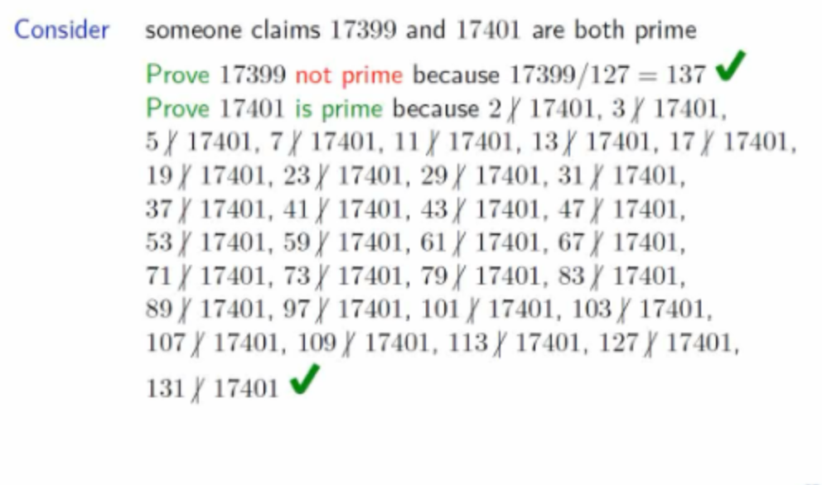

In this example we can prove it as seen by dividing by all the primes above.  
The method of proof statement holds for almost all natural numbers called induction.   
  
If something is true for some number and you can prove that it also holds for the successor number and you actually prove that it holds for the smallest number then it holds for all numbers and that is proof by induction.

Insertion Sort example because number of items shifted in the worst case is ‘all that are already sorted in each round’ is 1 in the 1st round, 2 in the 2nd round, 3 in the 3rd round, . . . , n − 1 in the last round together 1 + 2 + 3 + · · · + n − .    
  
We then looked at several examples as seen from slide 257-259. These were examples of what we have spoken about above using assumption and adding other numbers.  
  
Question Time!  
  
  
We were asked a few questions as a class and had to answer .. here is one of them

**Consider the following definitions**

V(0) = 2  
V(n) = (1/20V(n-1)+2

What is V(3)?  
  
Dr J then continued to  work out the answer on the board, I think we are okay with evaluating recursive formulas now.

**Towers Of Hanoi**  
  
The next step was the Towers of Hanoi game  
  
The **Tower of Hanoi** (also called the **Tower** of Brahma or Lucas' **Tower**, and sometimes pluralized) is a mathematical game or puzzle. It consists of three rods, and a number of disks of different sizes which can slide onto any rod.

Remembering the game is simply to move the towers from one side to another.  The practical from the week required editing code to get the computer to tell us the solution. We continued by analysing and discussing how this actually works

Assume insertion sort works for n items for size n + 1, after round with i = n − 1 first n items sorted correctly by assumption Observe item at position n is correctly sorted in Consequence n + 1 items sorted correctly

We do go through this is depth on the slides but this is difficult to articulate on portfolio because it was analysing numbers. Here is a link to the blackboard session for review later.  
  
[Here is a link to epic math](http://abercast.aber.ac.uk/Panopto/Pages/Viewer.aspx?id=b2194d55-e0f1-4b4a-bfb1-889b37e7d0ef)

Thank you Dr Jansen, what a semester! :p